Rhode Island Bar Association
CLE Seminar

Tax Lien Foreclosures

Sponsored by the
Rhode Island Bar Association
Foreclosure Prevention Project

March 20, 2018
1:00 – 2:30 p.m.
Rhode Island Law Center, Cranston

“Equity abhors forfeitures, and a petition to foreclose a property owner's right to redeem his or her property smacks of a forfeiture.”
Finnegan v. Bing, 772 A.2d 1070, 1072 (R.I. 2001)

Cities, towns, fire districts, water districts, and sewer authorities all need tax money to provide their essential services. When a property owner fails to pay in a timely fashion, the law allows the municipal authority to sell the tax lien. The purchaser of that lien may foreclose if it is not redeemed within one year. As a result, many poor and elderly homeowners lose their security in a dwelling and significant equity through this statutory scheme.

This seminar will seek to address the issues that arise from tax lien sales and foreclosures, to prepare practitioners to defend against the foreclosure on behalf of the homeowner. The speakers anticipate covering the following issues:

- Requirements for notifying the owner of the sale
- How the Madeline Walker Act works (or not)
- The procedures and timeline of a foreclosure case
- Requirements for notifying the owner of the foreclosure
- Remedies for failure to respond timely to the case
- Reviewing redemption costs for what is “reasonable”
- Interplay with redemption rights in bankruptcy court
- Past constitutional challenges and what issues remain

SPEAKERS

Jeffrey C. Ankrom, Esq.
Staff Attorney
Rhode Island Legal Services, Inc.

Michael Zabelin, Esq.
Staff Attorney
Rhode Island Legal Services, Inc.

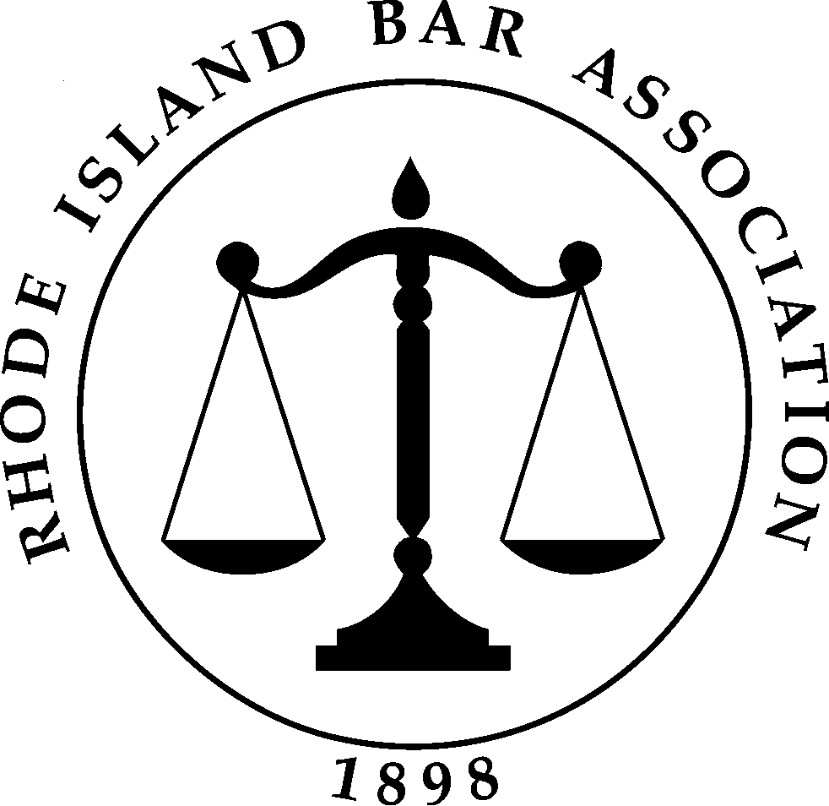

Subject to Supreme Court Rule IV this program has been approved
by the MCLE Commission for
1.5 RICLE credits.

This seminar is offered free of charge to all members of the
Bar Association Pro Bono Programs
and to those who agree to join a pro bono program prior to attending.
All participants must agree to accept a foreclosure prevention matter.

DATE/TIME/PLACE Tuesday, March 20, 2018
1:00 – 2:30 pm
RI Law Center, 41 Sharpe Drive, Cranston, RI
Lunch will be included.

WALK-IN REGISTRATION Pre-registration is strongly recommended to ensure your place at the seminar. If you have not pre-registered please call before the seminar to confirm that seats are still available. You must accept a pro bono case to attend this seminar. Call (401) 421-7799 or (401) 421-7758 or email jellis@ribar.com or eking@ribar.com .

SPECIAL ACCOMMODATION Please indicate on the registration form any special accommodation you may require or call (401) 421-7758.

INFORMATION Call the Public Service Programs (401) 421-7758, 421-7799 at the Rhode Island Bar Association.

Tax Lien Foreclosures
Tuesday, March 20, 2018
1:00 – 2:30 pm

Please complete a separate form for each registrant.

Name

Address

City State Zip

Phone Bar ID# email

In order to complete the registration process, you must accept a foreclosure prevention case in 2018. The staff will contact you with an available case or you may reach them at the listing above.

Mail form to:
Foreclosure Seminar
R I Bar Association
41 Sharpe Drive
Cranston, RI 02920
Or fax to 401-421-2703

